1. **Create VM**

* **Login to azure portal with plural sight email and password**

1. Login using the login detail provided in the PluralSight lab, skip the tour by clicking on “May be later”
2. On the search enter Virtual Machines

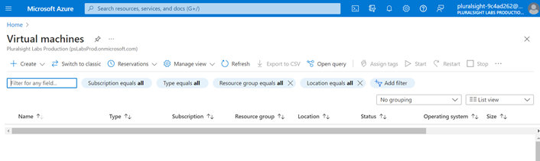

1. In the **Virtual machines** page, select **Create** and then **Azure virtual machine**. The **Create a virtual machine** page opens

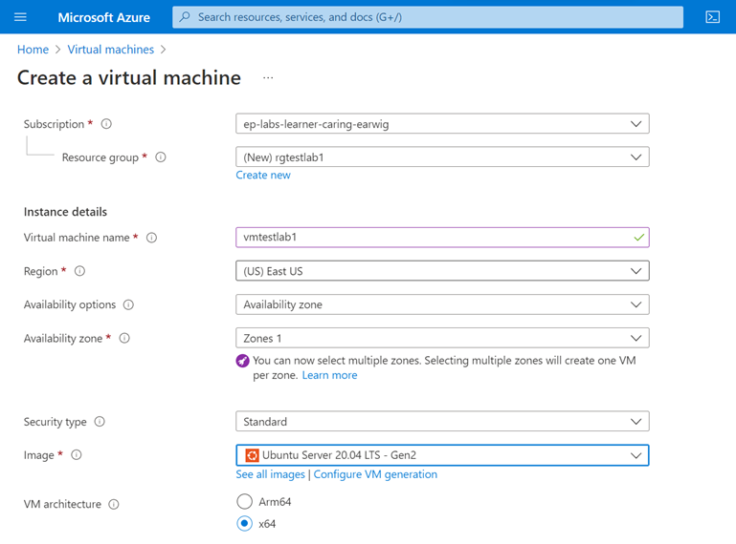

1. Under **Instance details**, enter *<VMName>* for the **Virtual machine name** and choose the default **Image Ubuntu server 20.4 LTS-Gen2**. Leave the other defaults.
2. In the Administrator account, select Authentication type “Password” option and provide the Username and Password. Leave the other defaults.

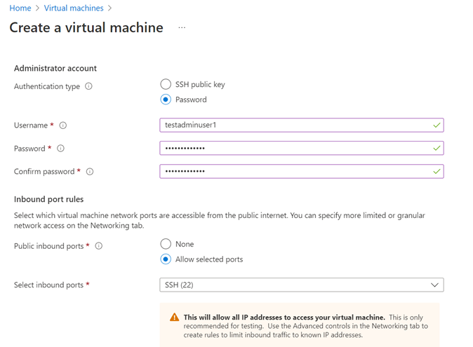

1. Click on “Review + Create”
2. Once the validation is passed, click on “Create”

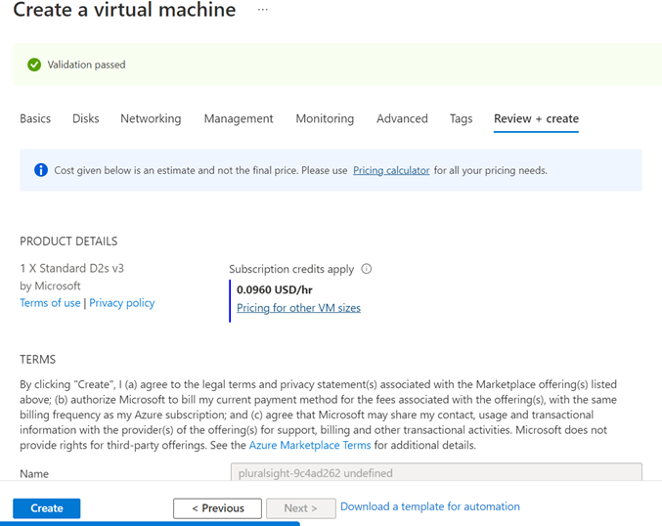

1. After the deployment is completed, all the resources created along with the VM is displayed.

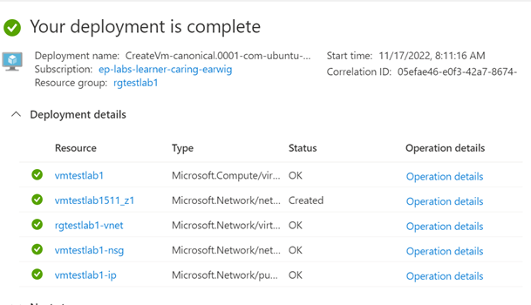

1. Select the Cloud Shell icon on the Azure portal to connect to login to the VM



1. At the bottom of the page, a new panel for Cloud Shell will appear. In the Welcome to Azure Cloud Shell prompt, click Bash.

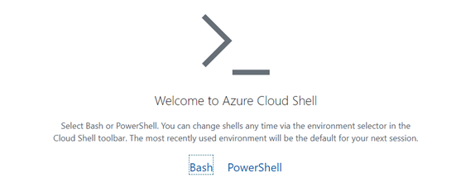

1. Click on “Create Storage” with default options

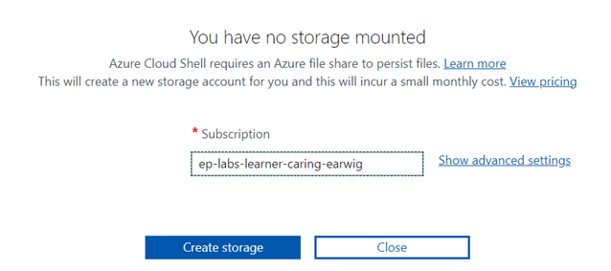

1. Once the storage is created the below screen will loaded.

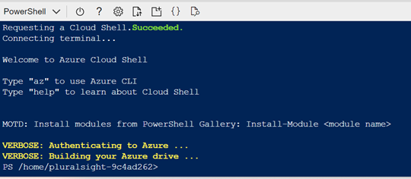

1. Provide the **ssh <username>@<vm-ip>**, provide the password when prompted to complete the login.

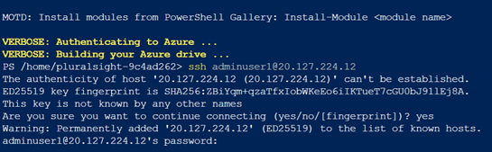

1. Use exit command to exit the VM.
2. **Creating Azure Database for Postgres server via CLI using ARM template**

* **Command to create DB using CLI .**

**-------------Copy the below commands in red to the azure CLI and press enter ---------**

read -p "Enter a name for the new resource group where the server will exist:" resourceGroupName &&

read -p "Enter the location for PostgreSQL server's administrator account name:" Location &&

az deployment group create --resource-group $resourceGroupName --template-uri https://raw.githubusercontent.com/DivyaGopinath1984/ARM-Template/main/template.json &&

read -p "Press [ENTER] to continue: "

**------------------------------------------------------------------------------------------------------------**

Provide resource group name as **rgtestlab1** *(Please provide the same resource group which is already created)*

Provide location as **eastus**

Provide servername as <postgreservername> (sample testdemoserver123, give uniquename **)**

Password **Demodb123456**

           Azure Postgres DB is created

* **Connect to DB from VM**

login to VM via CLI

ssh VMusername@VM-ip

* **Connect to the server**

Install updates for the Postgres connection  in your Linux VM

1. sudo apt-get update
2. sudo apt-get install postgresql-client
3. wget --no-check-certificate <https://dl.cacerts.digicert.com/DigiCertGlobalRootCA.crt.pem>

Replace the <postgreservername> with servername created in the above steps.

1. psql --host=<postgreservername>.postgres.database.azure.com --port=5432 --username=testdb123@<postgreservername> --dbname=postgres --set=sslmode=require --set=sslrootcert=DigiCertGlobalRootCA.crt.pem

* **Create Table**

create table inventory (id serial primary key,name varchar(50),quantity integer);

* **Insert records to the Table**

INSERT INTO    inventory (id,name,quantity) VALUES   (1,'Samsung',100);

INSERT INTO    inventory (id,name,quantity) VALUES   (2,'Iphone',100);

Select * from inventory ;

You will be able to see the records in the CLI

